Release 4.0

*Summer 2019*

Educational Plan Document Management Solution: Administrator’s Guide

Microsoft® Azure™, Microsoft® Office 365™, Microsoft® 365™ and SharePoint™, are trademarks of Microsoft Corporation. or its affiliates and are registered in the U.S. and other countries. PowerSchool is a trademark of PowerSchool Group LLC or its affiliates. Smart Technology Solutions, Great Technology People™ is a trademark of Axis Business Solutions, LTD. or its affiliates. Other names may be trademarks of their respective owners.

© 2019 Axis Business Solutions, LTD. and its affiliates.

Contains confidential and proprietary information of Axis Business Solutions and its subsidiaries. Use of these materials is limited to Axis Business Solutions licensees and is subject to the terms and conditions of one or more written license agreements between Axis Business Solutions and the licensee in question.

In preparing and providing this publication, Axis Business Solutions is not rendering legal, accounting, or other similar professional services. Axis Business Solutions makes no claims that an institution's use of this publication or the software for which it is provided will guarantee compliance with applicable federal or state laws, rules, or regulations. Each organization should seek legal, accounting and other similar professional services from competent providers of the organization's own choosing.

Prepared by:

Axis Business Solutions, LTD.

57 Green Street

Portsmouth, New Hampshire 03801

United States of America

Publication History

|  |  |
| --- | --- |
| Publication Date | Summary |
| June 27, 2019 | New version that supports revision 4.0 of the software.  Added configuration details which are newly supported in revision 4.0.190520 |
| August 15, 2019 | Updated information related to scheduled tasks. |

Table of Contents

Introduction 4

Prerequisites 4

Access Requirements 4

Platform Components 5

SharePoint Online 5

Site Collection 5

Drop Off Library 6

Master Document Library 6

School Team Permission Groups 7

User Interface 8

Student Information System 9

Script Processing Server 9

Environment Requirements 9

Additional Software 9

Application Structure 10

Configuration File 10

Document Intake and Permissions Processing Script 10

Launching the Document Processing Script 11

Document Access Audit Log Processing Script 11

Launching the Access Audit Log Processing Script 12

Process Automation 12

SIS Export 12

Scheduled Tasks 13

Applied Usage Scenarios 14

Experience 1: Teacher 15

Experience 2: Case Manager 16

Experience 3: School Team 17

Experience 4: School or District Administrator 18

Appendix 19

Process Diagram 19

Sample Export File 20

Configuration Details 21

Document Processing Configuration 21

Document Auditing Configuration 23

UI Configuration Option Details 24

IEP/504 Document Library Name 24

Audit Log List Name 24

User Interface Mode 25

Document Preview Preference 25

Data Export 25

Date Inspection Mode 25

Using the Windows Task Scheduler for Automation 27

# Introduction

Axis’ Educational Plan Document Management Solution, (EPDMS), provides your school, (or educational collaborative), a set of tools with which you can automate the secure management and delivery of`` materials related to students’ individual education and/or accessibility support plans. (IEP/504).

In conjunction with data from your student information system, (i.e. PowerSchool), the application builds a secure storage mechanism, based on the state-of-the-art SharePoint Online framework. New or updated plan documents are imported, classified and automatically shared with those responsible for administering a given student’s educational plan.

As a student’s educational support team changes, so do the permissions associated with that student’s plan documents; thus, keeping your school compliant and enabling opportunities to report on related activity.

## Prerequisites

Due to the highly customizable nature of the software, this platform requires installation by the Axis Professional Services team. Basic installation requires the items listed below.

* An Office/Microsoft 365 Subscription which:
  + Is successfully synchronized with an on-premises domain
  + Includes licenses for SharePoint Online, assigned to any user who will use the EPDMS platform.
  + Has audit Logging features enabled, as described [here.](https://docs.microsoft.com/en-us/office365/securitycompliance/search-the-audit-log-in-security-and-compliance)
* A script server for running PowerShell (v5+) scripts. The server must:
  + Run Windows 2012 R2 (or above), or be a dedicated desktop computer running Windows 10 (or above)
  + Run PowerShell version 5 or later
  + Have the SharePoint Patterns and Practices (PNP) module for SharePoint Online, version 3.0 (or above) installed.

### Access Requirements

A dedicated service account is used by this solution to manage multiple aspects of your Office/Microsoft 365 tenant and SharePoint Online instance. This should be a cloud-only account that has been assigned [Global Administrator](https://support.office.com/en-us/article/add-another-admin-f693489f-9f55-4bd0-a637-a81ce93de22d) role. A suggested name for the account is “Axis_EPDMS_Service.” A strong password is critically important.

⚠ **WARNING:** *Safeguard this account as you would any which is granted full administrator rights!*

# Platform Components

The below components comprise the Axis EPDMS platform.

## SharePoint Online

SharePoint serves as the main point for document interaction. The EPDMS installation process creates a dedicated area known as a ‘site collection’. This allows for easy installation in your environment, regardless of whether your school is already using SharePoint or not. If SharePoint is already in use, linking these areas is easily done later.

### Site Collection

The SharePoint site created to host the platform and document library. The default location is https://<your_tenant_name>.sharepoint.com/sites/iep-504.

After installation, the site will provide a basic framework for interaction with documents, as shown in the figure below. This site can be customized using standard SharePoint administration conventions to suit your school’s needs and / or branding standards.

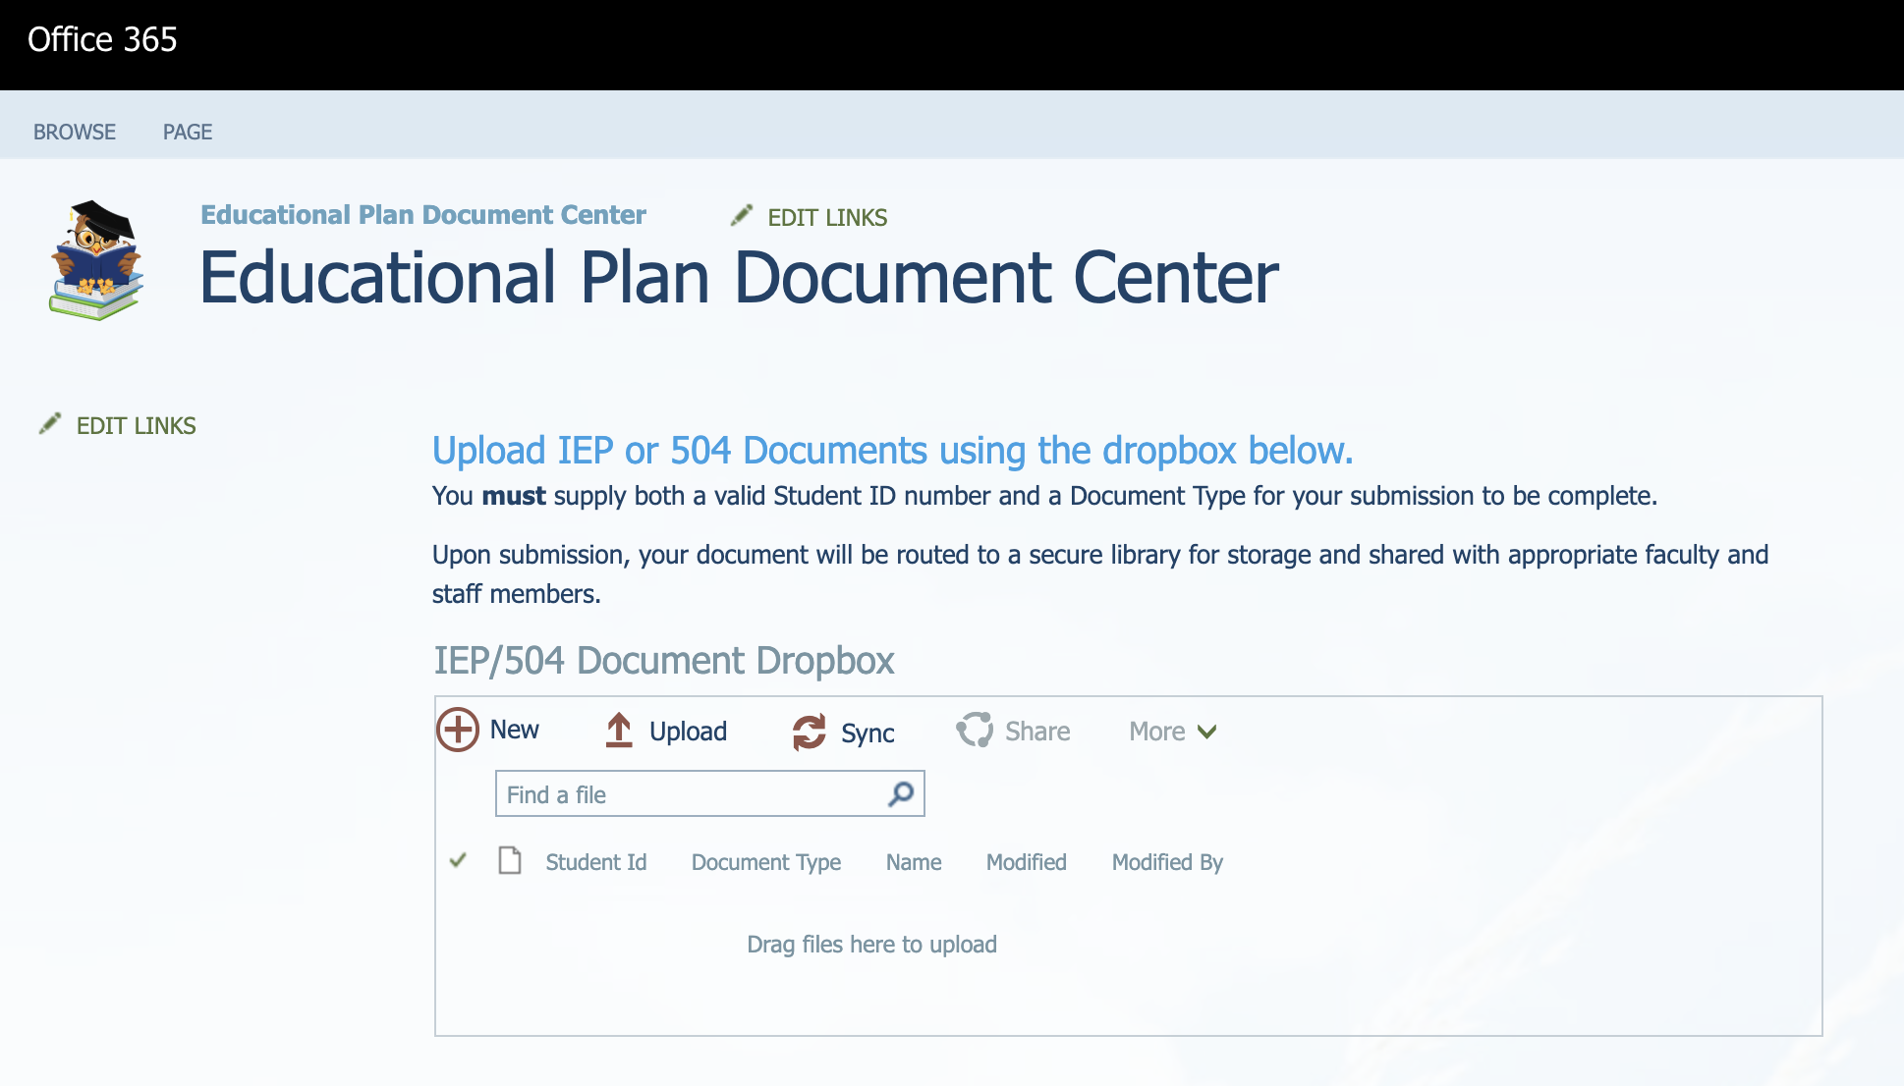

Figure 1 - EPDMS Site Collection Home Page

#### Drop Off Library

This library is where users will upload new documents. The default location of this library is:

https://<your_tenant_name>.sharepoint.com/sites/IEP-504/IEP 504 Dropbox.

After default installation, the library is exposed as a “drop box” on the EPDMS site, as shown in the figure below. Users can upload documents to this area. Upon supplying the fields necessary to associate a document with a particular student, the document is queued for intake and processing.

During processing, documents are moved from the drop box to a “master” document library. Documents in the master library become properly classified and secured; made accessible only to those who are part of the student’s academic support team.

⚠ **Note:** *Using SharePoint to manage the permissions of this document library directly is not recommended, as the EPDMS applications scripts control the processing of documents and their related permissions. Changing permissions directly could have unintended consequences.*

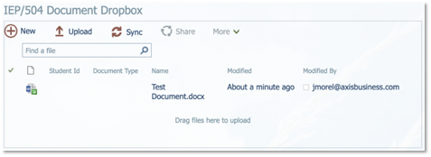

Figure 2 – Document drop box

#### Master Document Library

The library which houses documents that have been processed resides in the default location of

https://<your_tenant_name>.sharepoint.com/sites/IEP-504/IEP 504 Documents.

While users can find links to this library, it is generally not intended for general user interaction.

While SharePoint power-users may have a preference to view documents directly in the library, the EPDMS platform has its own user Interface, offering display and grouping options designed by schools who partnered with Axis during early development phases. This user interface, is further detailed below.

This said, there is no security risk for users who choose to seek out and use the native document library. SharePoint document library views are generated dynamically for the logged-in user, showing only those documents, for which they have access.

⚠ **Note:** *Using SharePoint to manage the permissions of this document library directly is not recommended, as the EPDMS applications scripts control the processing of documents and their related permissions. Changing permissions directly could have unintended consequences.*

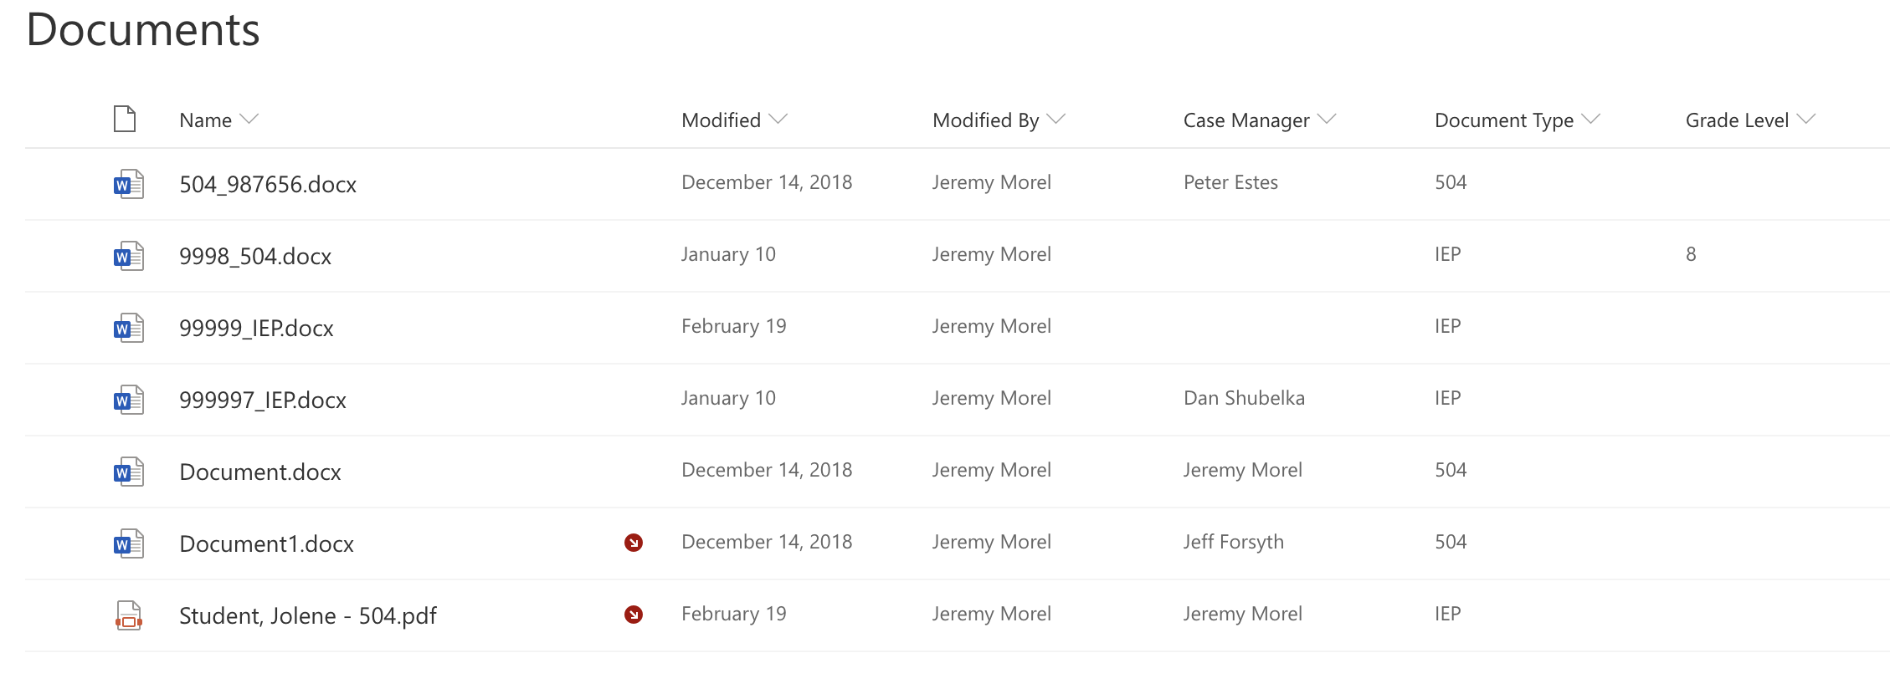

Figure 3 - Master Document Library (Default SharePoint View)

#### School Team Permission Groups

The process which evaluates document permissions uses data from the student information system to grant access to the student’s teacher(s) and/or case manager. Additionally, it is also possible to grant permissions to a particular group of users which should oversee a document, regardless of whether or not they are part of a student’s academic team.

For example, a school’s special education department may desire for its staff to see all documents, regardless of whether the member(s) are listed as the given student’s teacher.

To facilitate this concept, a user group in SharePoint is used. These groups should be created using standard SharePoint administration procedures. Groups should generally be named in a convention that includes the name of the group, as well as the school’s abbreviation. (i.e. “Student Services – RHS”) Naming conventions can be configured slightly via a configuration file mentioned later in this document.

#### User Interface

Provided as a preferred alternative to traditional document library views, the “Document Dashboard” web part offers several options to present a meaningful data array to several different consumer experiences.

The Document Dashboard Webpart can be added to any SharePoint page within your EPDMS site, where you wish to provide a user with a listing of, and access mechanism to, the documents to which they have been granted access. Additionally, the webpart is used to highlight documents which have not been opened, as well as alert users to re-open any document which has had recent changes, which should be reviewed. This feature is designed to assist with compliance needs related to the timely distribution and understanding of your students’ educational plan materials.

As shown in the figures below, the Document Dashboard web part can be found under the IEP/504 category, when editing a web part page. When added to a page, it displays document information, tailored the current user who is viewing the page.

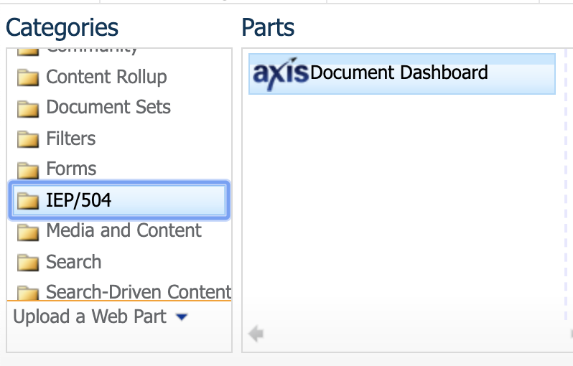

Figure 4 - Document Dashboard web part location

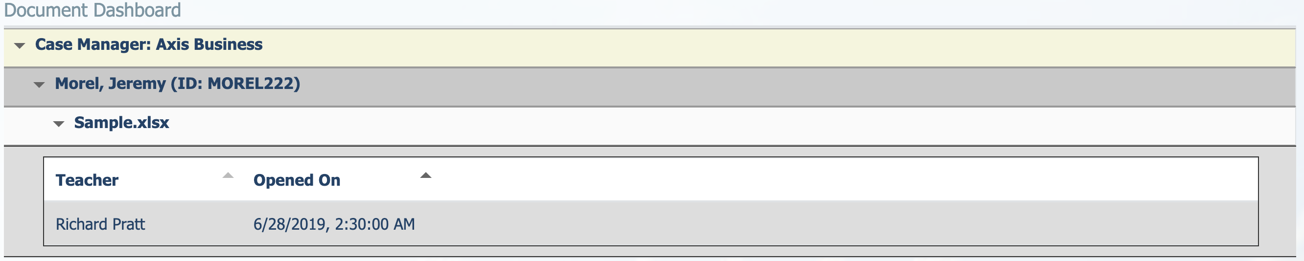

Figure 5 - User Interface

The web part offers several configuration options, described later in this document’s appendix, which allow various output modes, making the web part suitable several different user experiences. Since SharePoint does not limit the number of distinct pages on which a web part can, our recommendation is to simply create differently-configured pages, targeted for use by various types of end users.

## Student Information System

The ability to associate a document with a student record, as well as to determine which teachers should be given rights to a particular student’s document(s) are gleaned from data provided by the school’s student information system, (SIS).

In an effort to accommodate the widest range of potential data systems, the EPDMS processing scripts are configured to receive regular exports from the SIS, rather than extract them.

Typically, an export must contain information for all enrolled students, as well as details on current teachers, and if applicable, Case Managers and Student Team Members.

## Script Processing Server

### Environment Requirements

The EPDMS system was created using the Microsoft PowerShell scripting language. PowerShell was specifically selected for this application design due to its ability to easily be extended or modified to suit the needs of your particular school district and/or installation environment. Please be aware that changes to the application, while permissible, may introduce complexities that must be considered during upgrade to a new version. We highly recommend that you maintain copies of the base script, as well as regular backup copies of the script folder, so that inadvertent changes don’t cause delays or down time.

To utilize the EPDMS PowerShell scripts, you will need a Windows 2008 R2, (or higher), server with PowerShell v5 or greater installed. Alternatively, a dedicated Windows 10 Desktop will work.  This server will need to be able to access the internet—specifically all Microsoft websites, which are necessary to administer your Office 365 Tenant.  While *technically* *speaking* a dedicated server is not required for this purpose, it is recommended. As PowerShell is a scripting platform, it does not make use of advanced memory and processor management and is generally “unaware” of other applications which may run on the same system. A dedicated machine will ensure appropriate processing power. Some customers have had success using an existing domain controller and/or the server which runs the Azure AD Connect synchronization engine.

### Additional Software

In addition to requiring PowerShell binaries, your server will also require The Microsoft Azure Active Directory PowerShell Management Module, (see: <https://docs.microsoft.com/en-us/powershell/azure/active-directory/install-msonlinev1?view=azureadps-1.0>), as well as the Patterns and Practices (PnP) PowerShell Module for SharePoint Online, (see: <https://docs.microsoft.com/en-us/powershell/sharepoint/sharepoint-pnp/sharepoint-pnp-cmdlets?view=sharepoint-ps>). These are typically installed for you during the initial installation performed by the Axis Professional Services team, however, will be required if you ever decide to relocate your scripts to another computer.

### Application Structure

The scripts placed on your server have a distinct directory structure, which must be maintained due to internal dependencies. The structure and purpose of each file is described in the table below:

|  |  |  |
| --- | --- | --- |
| File / Folder Name | | Purpose |
| AuditLogProcessing.ps1 | | Script used to obtain Audit data for the files in your EPDMS environment. Typically, this process is scheduled to be run as an automatically recurring task. |
| IEP504_Configuration.ps1 | | The master configuration file. Contains options for managing the document processing and auditing. |
| Process-IEP504Documents.ps1 | | Script used for intake and processing of document metadata and security in your EPDMS environment. Typically, this process is scheduled to be run as an automatically recurring task. |
| Executables | | Executable batch files used to formally start the processes. Use the files in this folder when scheduling tasks. |
|  | Process Documents.cmd | Starts processing of EPDMS documents. |
|  | Process Audit Log.cmd | Starts processing of Audit Log Data. |
| Exports | | Suggested location for storing exported data supplied from your Student Information System. |
|  | PS-Export.txt | Sample SIS Export File, possibly used as a template. |
| Logs | | Suggested location for process output logs. |
| Resources | | Process Resources Folder. Generally, contents should not be modified. |
|  | AuditLog_Functions.ps1 | Core logic for the audit log retrieval functions. Changes to this file are not generally recommended. |
|  | IEP504_Functions.ps1 | Core logic for the document processing functions. Changes to this file are not generally recommended. |

### Configuration File

Configuration options are stored in the IEP504_Configurations.ps1 file. There are two distinct regions; one for document processing, the other for document auditing. The configurations in this file will impact operations performed in the AuditLogProcessing.ps1 and Process-IEP504Documents.ps1 scripts. Full details of the configuration options are found in the appendix of this document.

### Document Intake and Permissions Processing Script

The Process-IEP504Documents.ps1 script is responsible for the intake of documents placed in the EPDMS drop box library in your SharePoint environment. New documents are inspected, and when possible associated with a student’s demographic details. This is done by comparing SharePoint document details –primarily a supplied Student ID number—with details found in an export file from your Student Information System. Document are moved from the drop box to a “master” document repository served by a second document library within your EPDMS SharePoint Site.

In addition to assimilating student data and relocating documents from the drop box, the process also inspects documents currently inside of the master document library, processing any changes to data which may be already associated. For example, a change to the spelling of a student’s name, or reassignment to a new Case Manager in your SIS would prompt a commensurate change of the data associated to any documents associated to that student’s identity.

#### Launching the Document Processing Script

This script can be run in both an on-demand or scheduled task capacity. Once it is fully integrated into a production environment, it is typically recommended to schedule this task with relative frequency. This can be done in a way of your choosing; however, it is most commonly done using the Windows Task Manager. Steps for scheduling a task using the Windows Task Scheduler are found in this document’s appendix. The task is dependent upon data exported from your student information system, described later in this document.

When launched the script for the first time, (or after certain user account changes), you will be prompted for administrative credentials for running the script. These are the same credentials described earlier in this document.  Once supplied, the credentials are securely stored in an encrypted file, stored in location specified in your configuration file. The credentials are kept in accordance to best practices [recommended by Microsoft for PowerShell Security](https://docs.microsoft.com/en-us/powershell/module/Microsoft.PowerShell.Security/?view=powershell-5.1).

The process performs various operations necessary to read and process any documents within the libraries of your EPDMS SharePoint site.

During process completion, the script will output a “bookmark” file. This file is used on successive runs of the Process-IEP504Documents.ps1 script. The script logic will compare the bookmark file to the latest SIS export file in an effort to ensure that only documents which require an update will be processed. This prevents the need for the script to examine and process every single document in the master library. This is necessary as the library will eventually grow quite large, thus causing the process to run for an exceptionally long time.

Occasionally, there may be a reason you would wish for the process to re-examine and process the entire library. An example would be if a SharePoint administrator made global changes which overwrote or destroyed some of the document metadata. In this case, you can run the script with the bookmark file ignored by temporarily changing the IgnoreBookmark option in the IEP504_Configurations.ps1 file to $true and running the Process-IEP504Documents.ps1 script manually. This will cause the script to run for a very long time. You may wish to consider pausing execution of any scheduled jobs so that they do not interfere with the running of this process. Be sure to reset the bookmark option once the process finishes.

### Document Access Audit Log Processing Script

The AuditLogProcessing.ps1 script is designed to work in tandem with the document processing script described earlier in this document. It makes use of data, captured in the [Office 365 Security and Compliance Center](https://protection.office.com/). To use this functionality, you must [enable audit capture and search](https://docs.microsoft.com/en-us/office365/securitycompliance/turn-audit-log-search-on-or-off). This is generally done during your installation, but ongoing enablement is required.

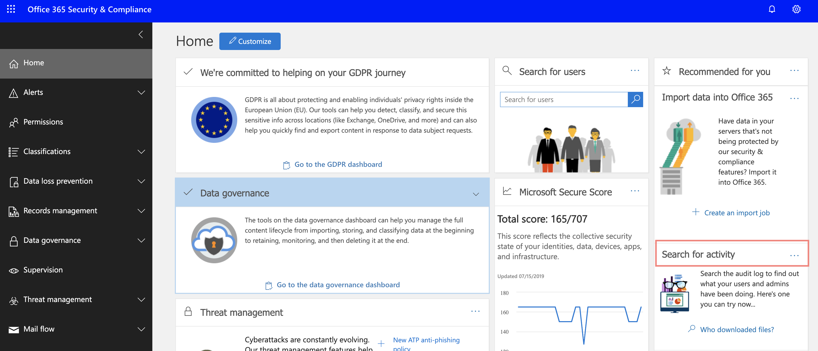

Figure 6 - Office 365 Security & Compliance Center

#### Launching the Access Audit Log Processing Script

Upon execution, the script will connect to your Office 365 tenant using the same credentials provided to the document processing script. This script will retrieve a subset of user activity data which is relevant to your EPDMS SharePoint site and the files contained in its libraries. This abbreviated dataset is then stored inside of a SharePoint list within your EPDMS site. This list is intended for use with the Document Dashboard User Interface webpart.

⚠ **Note:** *Do not modify the data contained in the IEP 504 Audit Log SharePoint list located within your EPDMS SharePoint site. Changes to this data could impact information accuracy.*

Configuration options for the Audit log processing script are located in the IEP504_Configurations.ps1 file. Full details of the configuration options are found in the appendix of this document.

# Process Automation

## 

## SIS Export

The data you export from your student information system is used by the script to process metadata and security changes for the documents in your EPDMS SharePoint site. As information in your SIS is expected to change with some frequency, it is important to consider a regular export of the data in coordination with successive runs of the document processing and audit log retrieval scripts. The typical suggestion is that your SIS export occur at least daily, at a time scheduled so that the resulting file is placed in the appropriate location, prior to the running of the document processing script. (The Audit log utility does not depend directly on the SIS export and can be scheduled independent of this concern.)

The SIS export typically will contain data representing all of your students’ current class enrollments, however this can be limited to an abbreviated population for efficiency if desired. For instance, you may wish to export only students who are identified as having an IEP and/or 504 plan.

At a minimum, the export should contain the following class enrollment data:

Date Enrolled (Class Start Date)

Date Left (Class End Date)

Student Number / ID

Additional Student Identifier, Web ID

Student First Name

Student Last Name

School Abbreviation

Class of Year

Grade Level

Home Room (Name/Number)

Team (Name)

Case Manager User ID

Class Teacher Email Address

Student Education Plan Type (IEP or 504)

It is expected that there may be multiple rows exported for students who are enrolled in multiple classes. The document processing script will appropriately handle this case.

## Scheduled Tasks

The processes which comprise this application are typically recommended to be run as scheduled tasks with relative frequency. This can be done in a way of your choosing; however, it is most commonly done using the Windows Task Manager.

Our customers often find success running the document processing script once per day, following successful placement of the SIS export file. We recommend running the document audit log process multiple times per day so that access warnings in the User Interface are updated in a timely manner. Steps for scheduling a task using the Windows Task Scheduler are found in this document’s appendix.

Note: The ability for a regularly scheduled SIS export will depend on your specific system’s capabilities. Please consult product documentation or your software vendor for assistance.

# Applied Usage Scenarios

The end user experience is defined, in large part, by our existing user community. Currently we have conveyed four distinct user experiences which seem to accommodate the needs of most customers. If your district has additional needs, please inquire with Axis Professional Services so we can assist.

## Experience 1: Teacher

In this experience, all documents for students on one of the teacher’s current rosters are shown. The results are grouped by student and show a visual indicator for any student whose document(s) the system determines has not yet been read by the current teacher.

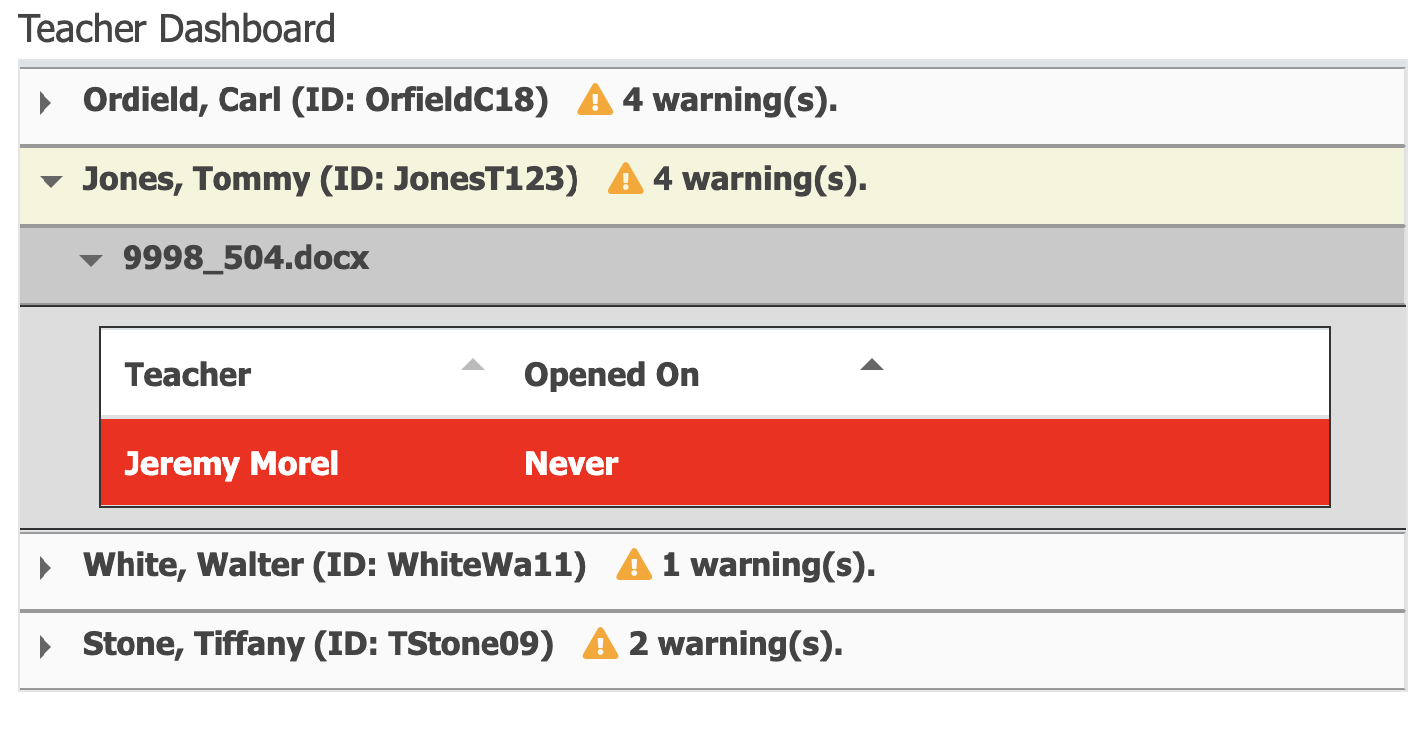

Figure 7 - Teacher View

## Experience 2: Case Manager

In this experience, all documents in the system, for students which the current user is listed as case manager, are shown. The results are grouped by student and show a visual indicator for any student whose document(s) the system determines has not yet been read by one or more of that student’s teachers.

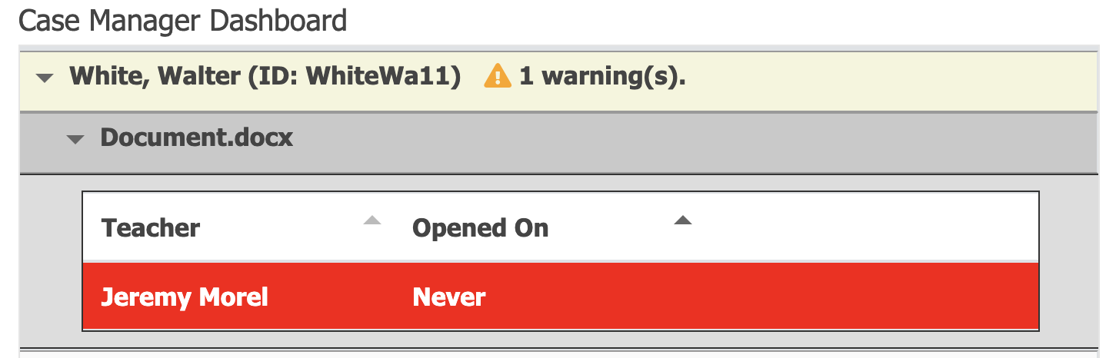

Figure 8 - Case Manager View

## Experience 3: School Team

In this experience, all documents in the system, for which the current user has access, are shown to the logged in user. The concept of School team is conceived around typical departmental personnel, such as those working in the Special Education or Disability Services department, who would require oversight to students’ documents, but are not necessarily their case manager or teacher. The results are grouped by the student’s case manager and show a visual indicator for any student whose document(s) the system determines has not yet been read by one or more of that student’s teachers.

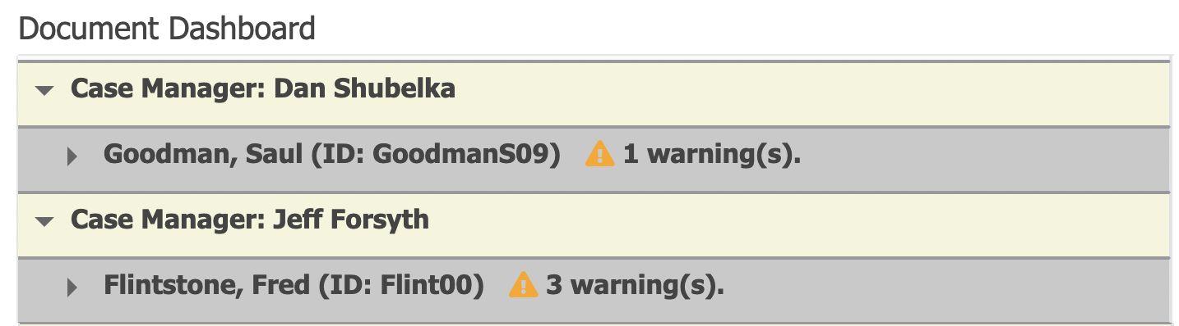

Figure 9 - School Team Member View

## Experience 4: School or District Administrator

In this experience, all documents in the system are shown to the logged in user. (The presumption is made that an administrator would have access to all documents in the SharePoint Site.) The results are grouped by the student’s case manager and show a visual indicator for any student whose document(s) the system determines has not yet been read by one or more of that student’s teachers.

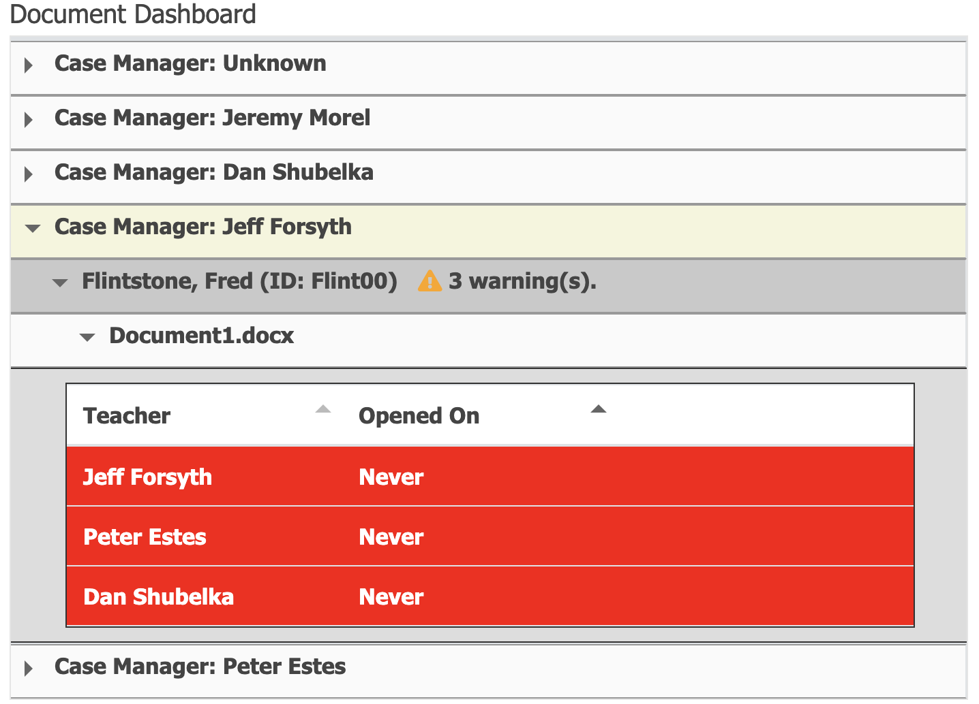

Figure 10 - School Administrator View

# Appendix

## Process Diagram

## Sample Export File

The SIS export file is used by the document processing application to associate student and teacher metadata with documents in your library. Below is a sample export, representing a mock school district with three students; a high school, middle school and elementary school enrollee. The records from each student represent individual classes, (and thereby the teachers who teach them), that each student is enrolled in. (This example is split into two images for viewing but is intended to represent a single export file.)

The export file should be in a tab-separated (preferred) or comma-separated format.

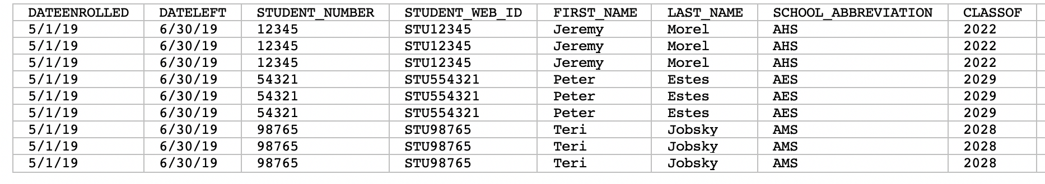

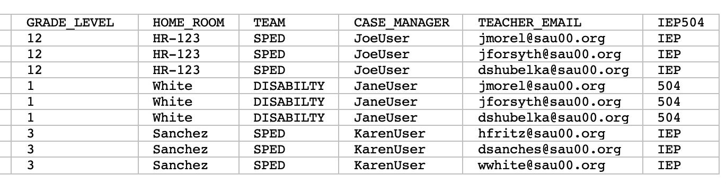

## Configuration Details

Configuration options are stored in the IEP504_Configurations.ps1 file. There are two distinct regions; one for document processing, the other for document auditing. Options are described in the tables below:

### Document Processing Configuration

|  |  |  |
| --- | --- | --- |
| **Property Name** | **Purpose** | **Example/Default Value** |
| ExportFile | SIS Export File Location | “E:\Exports\Students.txt” |
| OutputLog | Location where process output logs should be stored | “C:\Logs\MyLog.txt” |
| GrantAccessDaysBeforeStart | Number of Days Prior to Class Start that a Teacher should be allowed access to student's documents | 30 |
| GrantAccessDaysAfterEnd | Number of Days After class ends that a Teacher should retain access to student's documents | 30 |
| Columns | A PowerShell array of the relevant columns used in your SIS Export file. | @("DATEENROLLED", "DATELEFT", "STUDENT_NUMBER", "STUDENT_WEB_ID", "FIRST_NAME", "LAST_NAME", "SCHOOL_ABBREVIATION", "CLASSOF", "GRADE_LEVEL", "HOME_ROOM", "TEAM", "CASE_MANAGER", "TEACHER_EMAIL", "IEP504"); |
| DropBoxName | The name of the SharePoint library used for your document drop box. | “IEP 504 Dropbox” |
| DocumentLibraryName | The name of the SharePoint library used as the main storage for processed documents. | “IEP 504 Documents” |
| ForceCheckIn | If a document is checked out, force it to be checked in. ($true or $false). | $true |
| UseMFA | Used to specify whether the identity running the script requires multi-factor authentication. Note: This feature is experimental and intended for testing purposes only. It will not work with automated scheduling. ($true or $false). | $false |
| CredentialLocation | The location where the secure credential is found or should be stored. | “c:\my.credential” |
| SiteUrl | The SharePoint Site used in your EPDMS implementation | “https://sau00.sharepoint.com/sites/EPDMS” |
| BookMarkFile | The location where the secure credential is found or should be stored. | “C:\Axis\Bookmark.txt” |
| IgnoreBookmark | Used primarily in testing, specifies whether the bookmark file should be ignored, causing all entries in the current export file to be processed. ($true or $false) | $false |
| SimulationMode | Used in testing, provides a simulation of what would happen if the script was run in production. Output is mocked to screen and output log files. ($true or $false) | $false |
| RemaneFile | Rename document using Student ID and Document Type ($true or $false). | $false |
| SchoolTeamGroupPrefix | Used to denote a pre-existing SharePoint group used to grant access to a School Team, which should always get access to a particular document.  Groups should be named with the desired prefix, followed by the school abbreviation as contained in the export.  i..e. if prefix is "Student Services - ",and a school abbreviation is "HMS" the SharePoint group name should be "Student Services - HMS")  (Requires use of School Abbreviation in the SIS export file.) | “School Team – ” |

### Document Auditing Configuration

|  |  |  |
| --- | --- | --- |
| **Property Name** | **Purpose** | **Example/Default Value** |
| AuditListTitle | Title of the SharePoint List where document audit data is stored | “IEP 504 Audit Logs” |
| AuditIntervalMinutes | The “window” of transaction inquiries to pull at one time. 15 minutes is the recommended value. This will keep the process from timing out due to attempts to perform large queries. | 15 |
| AuditOutputLog | The location where output logs will be stored. | “C:\Logs\AuditLog.txt” |
| AuditRetries | The number of times the script will retry when zero entries are returned for a given query. This is used in cases where you expect possible network congestion causing an issue with log retrieval inquiry. 1 is the recommended value, as increasing will cause an exponential increase in the time the process takes to run. | 1 |
| AuditOperations | The default value retrieves all file access operations. It should not need to be changed. | “FileAccessed,FileDeleted,FilePreviewed” |
| AuditRecordType | The default file access operations. It should not need to be changed. | “SharePointFileOperation” |
| AuditResultChunkSize | This value is used to prevent overflow of the process. It limits the values that will be pulled in one query. 1000 is the recommended default value. Changing this is not recommended and should only be necessary if you find you are not getting all access results for a given file. | 1000 |
| AuditTimeToGoBack | This value represents the interval at which you intend to poll the audit log. The example indicates that you intend to poll the last two hours of data, relative to the time you launch the script. You should coordinate this with the frequency in which you schedule the audit log retrieval. | New-TimeSpan -Days 0 -Hours 2 – Minutes 0 |
| AuditDocTypes | A PowerShell array of document extensions that should be looked for in the auditing process. This list should contain ONLY the file types you are concerned with, as additional file types will cause the audit processing script to run for a very long time. | @('XLS', 'XLSX', 'DOC', 'DOCX', 'PDF', 'PPT', 'PPTX') |

## UI Configuration Option Details

The Document Dashboard UI Webpart is intended for use on any SharePoint page within your EPDMS site, where you wish to provide a user with a dynamic view of documents to which they have been granted access. In addition, it is used to highlight documents which have not been opened, in an effort to help with compliance needs related to the timely distribution and understanding of your students’ educational plan materials.

The figure below shows the configuration options of the Document Dashboard UI SharePoint webpart.

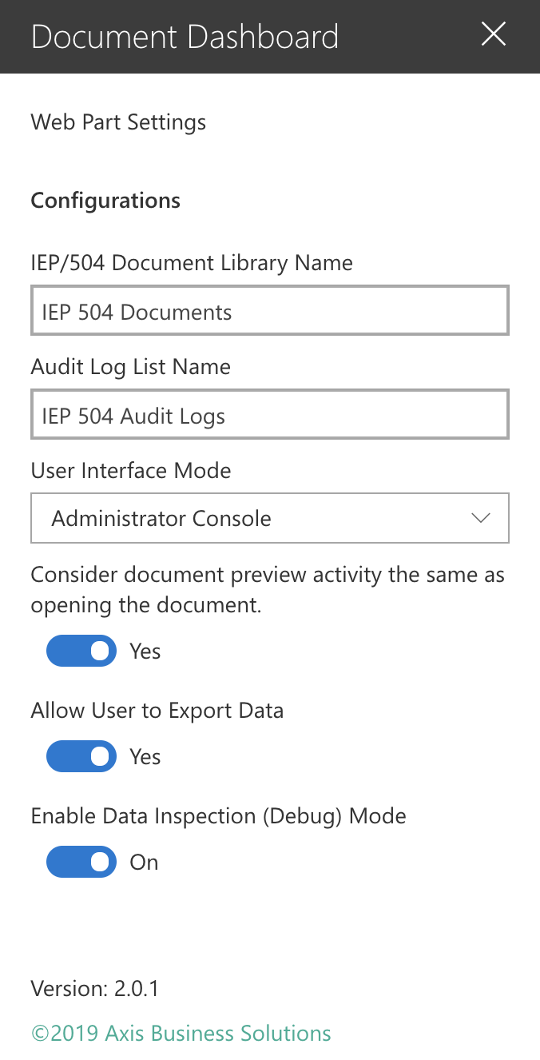

Figure 11 - Document Dashboard Webpart Configuration

The options configured on this panel impact how the web part will display relative document data on a page which has this webpart added to it. The details for each option are described below.

### IEP/504 Document Library Name

This is the name of the “master” document library where documents are stored in the SharePoint site. The default value is IEP 504 Documents. If you decide to change the location of your documents, this value must be updated.

### Audit Log List Name

This is the name of the SharePoint list which holds audit entries placed by the AuditLogProcessing.ps1 script. The default value is IEP 504 Audit Logs.

### User Interface Mode

This property consists of options which will appropriately format and group results, based on the intended audience. It is important to note that none of these options will expose documents or information to a user unless they have been granted explicit access. The options are instead intended to provide the most useful interface with regard to who is accessing the data.

|  |  |
| --- | --- |
| Mode | Usage Notes |
| Teacher’s Console | Used to display documents of “My Students” for a given teacher. The results displayed are only those documents for a student currently on a class roster of the teacher viewing the page. The results are grouped by student and show a visual indicator for any student whose document(s) the system determines has not yet been read by the current teacher. |
| Case Manager Console | Used to display documents of “My Students”, for a given case manager. The results displayed are only those documents for a student currently in the caseload for the case manager viewing the page. The results are grouped by student and show a visual indicator for any student whose document(s) the system determines has not yet been read by one or more of that student’s teachers. |
| Administrator Console | Used to display all documents in the system, for which the current user has access. This view can be used for a school team (such as the Special Education or Disability Services department), or for a school or district administrator. The results are grouped by the student’s case manager and show a visual indicator for any student whose document(s) the system determines has not yet been read by one or more of that student’s teachers. |

### Document Preview Preference

In some areas of SharePoint, a user can hover over a document and be shown a small, sometimes legible, preview. This option indicates whether the system should consider a document previewed using this method the same as it being deliberately opened and read.

### Data Export

Determines whether the user interface should display buttons which generate exported data and/or reports from the currently displayed dataset.

### Date Inspection Mode

Intended for use when trouble in encountered with the user interface. It displays the underlying data feed in JSON format. An example is shown below.

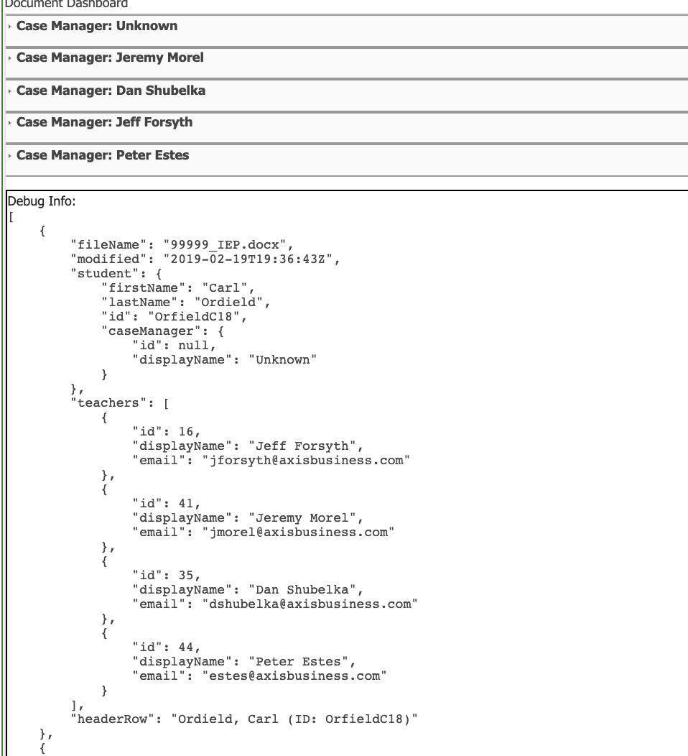

Figure 12 - Data Inspection Mode

## Using the Windows Task Scheduler for Automation

The scripts which comprise the the document processing, and audit log data retrieval processes, can be scheduled for automatic execution at an appropriately identified time and interval. Below are the steps used to schedule tasks using Microsoft Windows. There may be slight variations between versions of Windows, however the process is generally the same.

From the server used to execute your scripts, access the Windows Task Scheduler and create a basic task. You will be guided through the process to create a new scheduled job. Give your task a meaningful name and description, such as shown in the sample below.

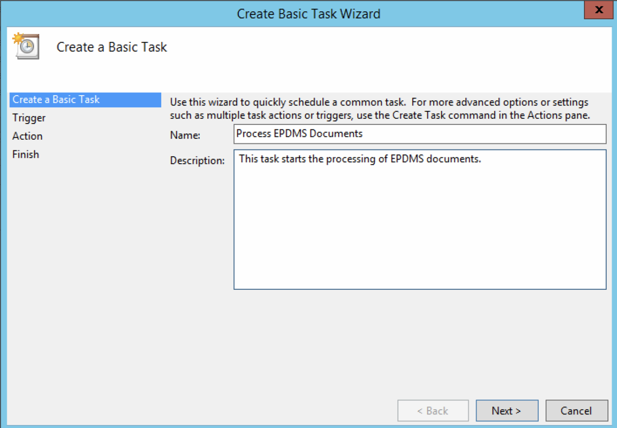

Figure - Creating a Basic Task

Continue through the wizard to set frequency and select the program to execute.

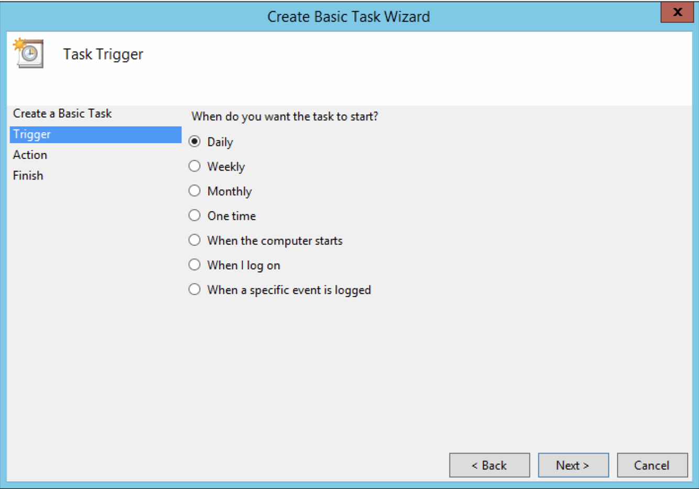

Figure - Task Frequency

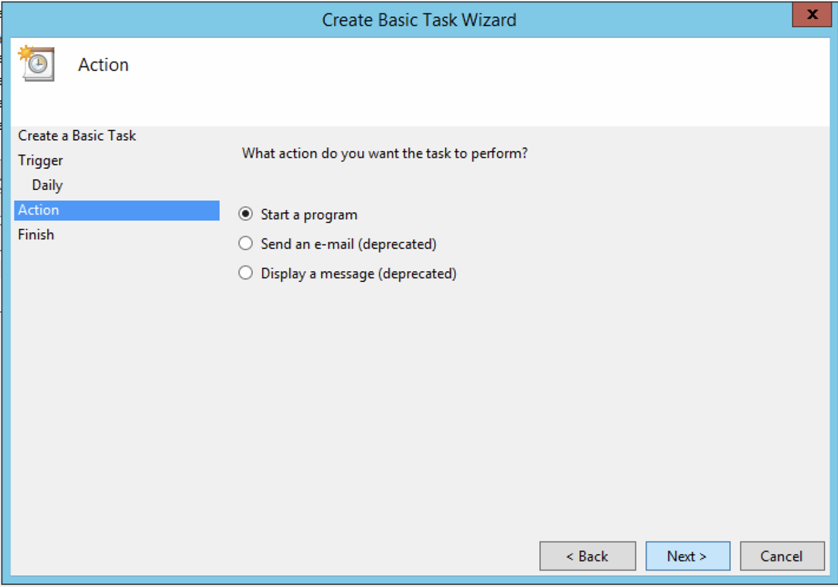

Figure - Task Action

Use the browse button to select the appropriate executable, based on the task you are setting a schedule for. Be sure to specify the start in value to match the main directory of your installation.

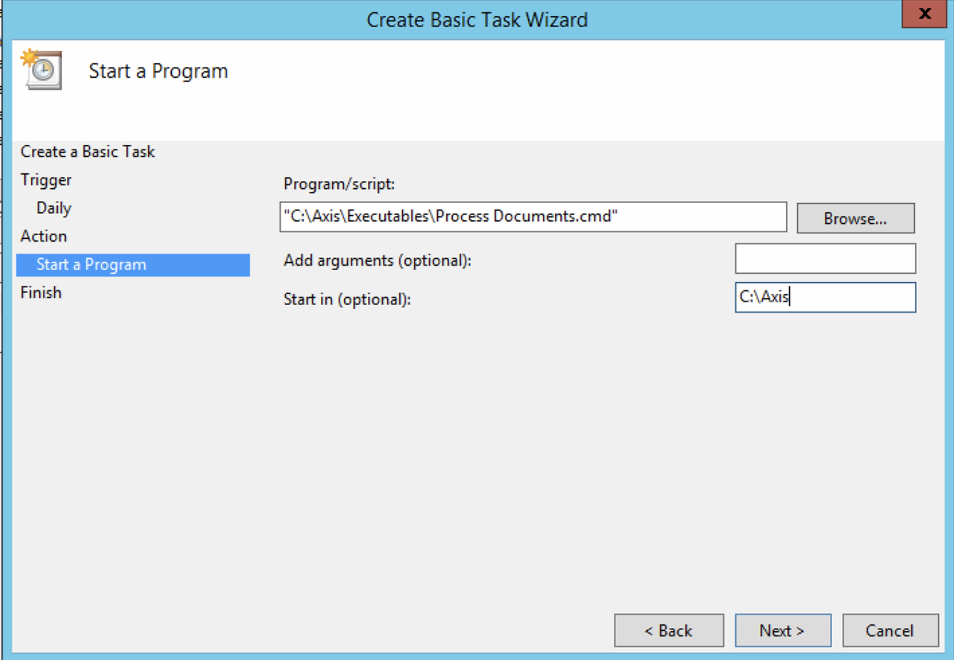

Figure - Program Definition

Selecting the ‘Open the Properties dialog…’ option will give you additional control for scheduling options, as well as the user whose context the task should run under.

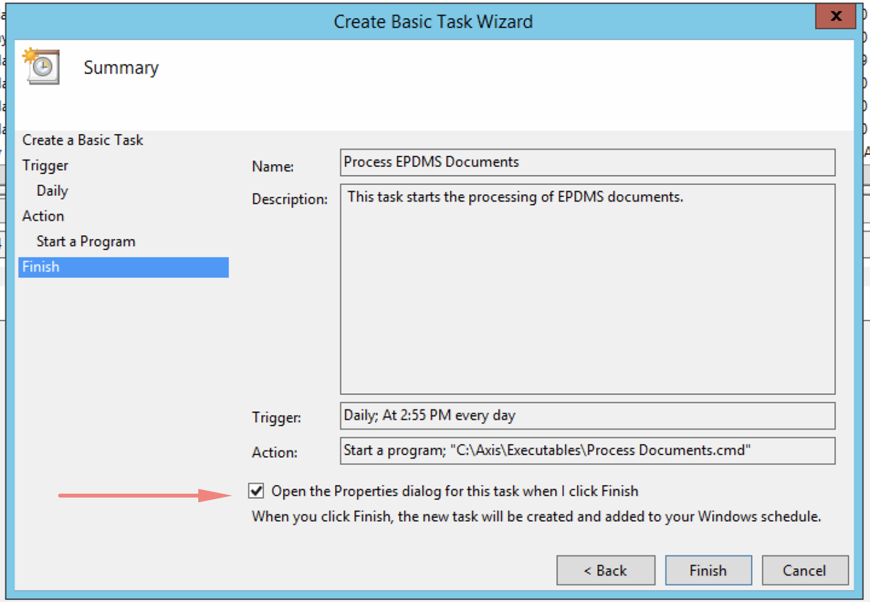

Figure - Settings Review



Figure - Execution User Context

Generally, the process will not run for longer than several hours. We recommend setting the ‘Stop task…’ option as shown in the figure below.

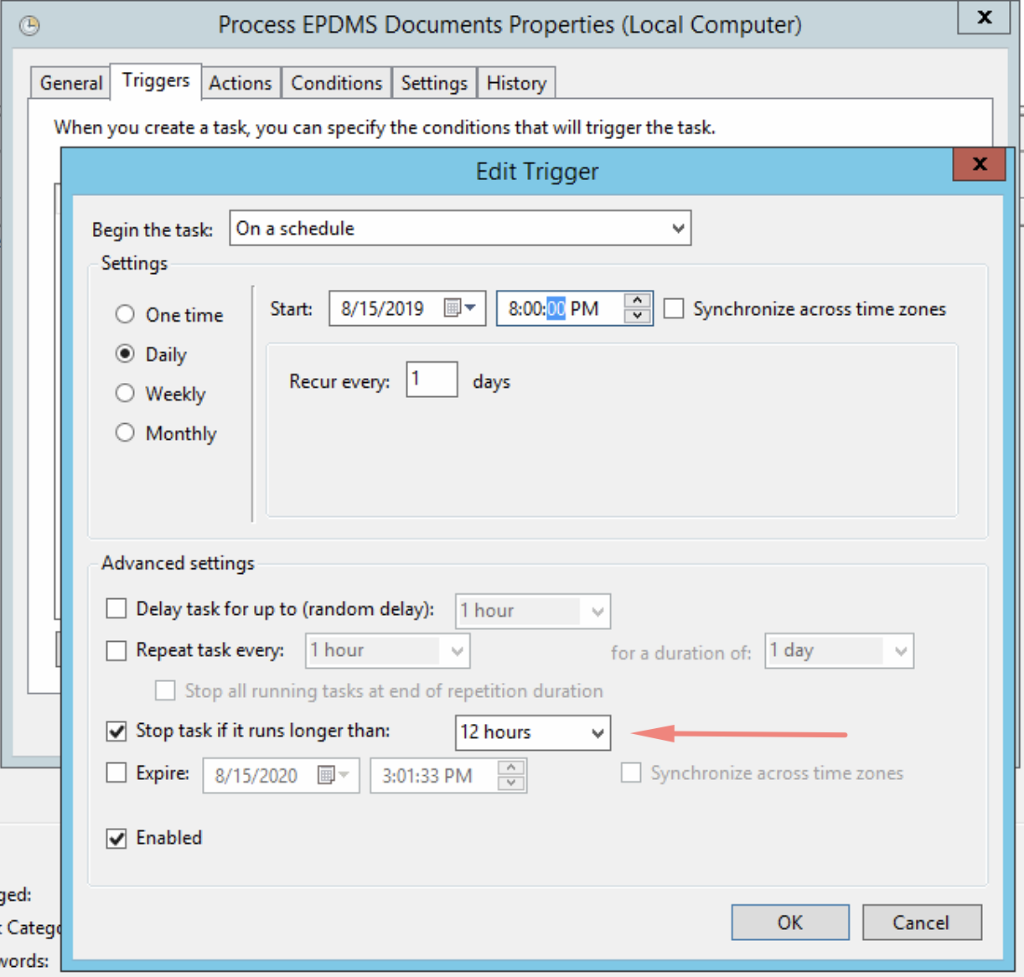

Figure - Schedule Refinement